

**NATIONAL ECONOMIC CONSULTATIVE FORUM**

**MONTHLY ECONOMIC BULLETIN**

**FEBRUARY 2025**

# Executive Summary

This bulletin focuses on economic developments for the month ending 28 February 2025 that include, world economic developments, international commodity prices, Zimbabwe Gross Domestic Product (GDP) growth updates, merchandise trade developments, exchange rate developments, inflation developments, monetary developments and stock market developments.

The global economy is expected to remain stable, with a projected growth rate of 3.3% in 2025 and 2026, building on a 3.2% growth rate in 2024. This stability is supported by declining inflation, softer commodity prices, and monetary easing. However, significant challenges persist, including ongoing conflicts, geopolitical tensions, trade restrictions, and climate risks. Global inflation is projected to decline to 4.2% in 2025 and 3.5% in 2026.

Commodity prices have exhibited a mixed fortunes trend, with agricultural commodities and crude oil experiencing declines on a month-on-month basis. Conversely, natural gas, aluminium, copper, nickel, and gold prices have increased by 25.95%, 0.49%, 5.92%, 2.36%, and 2.13%, respectively. The year-to-date trend mirrors these changes. The decline in oil prices can be attributed to slowing demand growth and increased production, while the surge in natural gas prices is driven by the global reliance on LNG as a transition fuel. Furthermore, demand for critical minerals is expected to continue rising, whereas international crop prices remain relatively low.

Zimbabwe's GDP growth is predicted to rise by 6% due to a stronger agricultural season, following a 2% downturn in 2024. The current pricing and exchange rate stability are likely to support the projected growth trajectory

Zimbabwe's merchandise trade in January 2025 totaled USD1.4 billion, a 11.4% decline from December 2024, but a 13.4% increase from January 2024. The trade deficit narrowed to USD96.8 million from USD196.9 million in December 2024. Exports totaled USD652 million, a 5.8% decline from December 2024, mainly due to lower gold, tobacco, and PGMs earnings, but 20.5% higher than in January 2024, with top destinations being the UAE, South Africa, and China. Meanwhile, imports totaled USD748.8 million, a 15.8% decline from December 2024, but a 7.9% increase from January 2024, with key imports including maize, diesel, petrol, and fertilizers, primarily from South Africa, China, Bahamas, and Mozambique.

During the review period, the ZWG depreciated against major currencies, including the USD, GBP, EUR, and ZAR. However, the parallel market exchange rate slightly dropped, while the official exchange rate steadily increased, resulting in reduced exchange rate premium. This shift was attributed to the Reserve Bank of Zimbabwe's (RBZ) tight monetary stance. Meanwhile, the USD experienced mixed performance, depreciating against the GBP, EUR, and ZAR, but gaining against the EUR on a year-on-year basis. The USD's depreciation is largely attributed to the impact of Trump's policies on business and consumer confidence.

ZWG's month-on-month inflation rate experienced a significant decline, dropping from 10.5% to 0.5% and weighted inflation fell from 11.6% to 0.3% between January and February 2025. This sharp decrease indicates growing price stability as businesses and consumers adapt to market conditions. Food, beverages, housing, and utilities remain the primary drivers of inflation.

Broad money stock stood at ZWG87.12 billion in January 2025, a 0.38% decline from ZWG87.45 billion recorded in December 2024. The foreign currency component of money supply grew by 0.62%. Money supply stock comprised of foreign deposits (84.08%), local currency deposits (115.8%) and local currency in circulation (0.12%). Money supply stock dropped by 0.38% in January 2025.

As of 28 February 2025, the average deposit rates for local currency savings increased to a minimum of 3.81% and a maximum of 4.14%, while foreign currency deposit rates ranged from 1.69% to 1.72%. Lending rates on foreign currency were also adjusted, with increases in minimum rates for individuals (12.81%) and corporates (10.93%), and a decrease in maximum rates. Additionally, weighted lending rates for local currency were revised upward for both individuals and corporates.

The Zimbabwe Stock Exchange (ZSE) and Victoria Falls Stock Exchange (VFEX) both experienced bearish trends in February 2025. The ZSE's All-Share Index, Top 10 Index, and market capitalization declined, however, value traded surged by 523.18%. The VFEX also saw declines in the All-Share Index, value traded, and market capitalization, indicating a downturn in investor sentiment.

**Table of Contents**

Executive Summary i

1.0 World Economic Developments 1

1.1 World Output 1

1.2 Global Inflation Developments 1

2.0 International Commodity Prices 1

3.0 Zimbabwe GDP Growth Update 2

4.0 Merchandise Trade Developments 2

5.0 Exchange Rate Developments 3

5.1 ZWG Exchange Rate Developments 3

5.2 Parallel Market Developments 3

5.3 Cross Rate Developments 4

6.0 Inflation Developments 4

7.0 Monetary Developments 6

7.1 Money Supply 6

7.2 Interest Rates 6

8.0 Stock Market Developments 7

8.1 Zimbabwe Stock Exchange (ZSE) 7

8.2 Victoria Falls Stock Exchange (VFEX) 7

9.0 Recommendations 8

10 References 9

**List of Tables**

Table 1: Commodity Price Movements – Month Ending 28 February 2025 1

Table 2: ZWG Exchange Rate Movements-Month Ending 28 February 2025 3

Table 3: USD Exchange Rate Movements–Month Ended 28 February 2025 4

Table 4: Monthly Inflation for February 2025 5

Table 5: Interest Rates as of 28 February 2025 6

Table 6: Zimbabwe Stock Exchange Movements 7

Table 7: Victoria Falls Stock Exchange Movements 7

**List of Figures**

Figure 1: Merchandise Trade Developments 2

Figure 2: Parallel Market Developments – February 2025 3

Figure 3: Month-on-Month ZWG Inflation Outturn 4

Figure 4: Month-on-Month Weighted Inflation Outturn 5

Figure 5: Broad Money (M3) Supply 6

# 1.0 World Economic Developments

## **1.1 World Output**

1.1.1 The global economy remains projected to be steady at 3.3% in 2025 and 2026 from 3.2% in 2024. According to OECD (2025), the global economy’s slow growth is due to higher trade barriers in several G20 economies and increased policy uncertainty weighing on investment and household spending. United Nations (2025) noted that global economic stability has been underpinned by continued disinflation, softening commodity prices, and monetary easing in many countries. However, ongoing conflicts, geopolitical tensions, and potential trade restrictions, as well as climate risks pose significant challenges.

## **1.2 Global Inflation Developments**

1.2.1 Global headline inflation also remains projected to decline to 4.2% in 2025 and further decline to 3.5% in 2026, IMF (2025).

# 2.0 International Commodity Prices

2.1 During the month under review, commodity prices exhibited a mixed fortunes trend. Prices of all selected agricultural commodities and crude oil declined. However, natural gas, aluminum, copper, nickel, and gold prices firmed by 25.95%, 0.49%, 5.92%, 2.36%, and 2.13%, respectively. The year-to-date trend of commodity prices is the same as the month-on-month trend. According to Bradstock (2025), oil price fall was due to a slowdown in demand growth and an increase in production, natural gas prices rise was due to reliance on LNG as a transition fuel by many countries across the globe. The demand for critical minerals is expected to continue rising. International prices for crops (wheat, maize, rice, and soybeans) remain lower (World Bank, 2025)

2.2 On a year-on-year basis, nickel, cotton, soyabeans, and wheat prices retreated by 10.62%, 34.57%, 11.16%, and 3.72% respectively, as shown in Table 1.

Table 1: Commodity Price Movements – Month Ending 28 February 2025

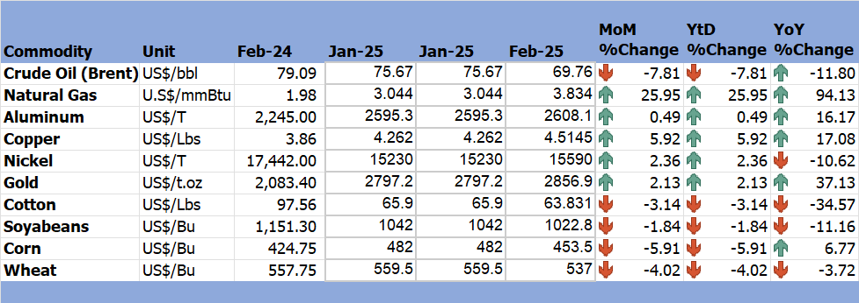

*Source: Trading Economics (2025)*

# 3.0 Zimbabwe GDP Growth Update

3.1 According to RBZ (2025), Zimbabwe's GDP growth is predicted to rise by 6% due to a stronger agricultural season, following a 2% downturn in 2024. The current pricing and exchange rate stability are likely to support the projected growth trajectory.

# 4.0 Merchandise Trade Developments

4.1 Zimbabwe National Statistics Agency (ZimStat) had not published the merchandise trade data for February 2025 by the time of compiling this report, thus the analysis is based on January 2025 data.

4.2 In January 2025, total merchandise trade amounted to USD 1.4 billion, reflecting a 11.4% decline from USD 1.58 billion recorded in December 2024 (RBZ, 2025). On a year-to-date basis, it grew by 13.4% from USD 1.23 billion in January 2024.

4.1 The country’s trade deficit stood at USD 96.8 million, an improvement from USD 196.9 million recorded in December 2024 (see Figure 1). Merchandise exports totaled USD652 million, a 5.8% decline from the December 2024 outturn of USD692.4 million. According to RBZ (2025), the decline was due to lower export earnings from gold, tobacco, and PGMs. Despite the monthly drop, exports were 20.5% higher compared to USD 540.9 million recorded in January 2024. Exports destinations were mainly the UAE, South Africa, and China. Merchandise imports totaled USD748.8 million in January 2025, reflecting a 15.8% decline from USD889.3 million recorded in December 2024 while it grew by 7.9% on a year-on-year. Imports were dominated by maize, diesel, petrol, and fertilizer mainly from South Africa, China, the Bahamas, and Mozambique.

Figure 1: Merchandise Trade Developments

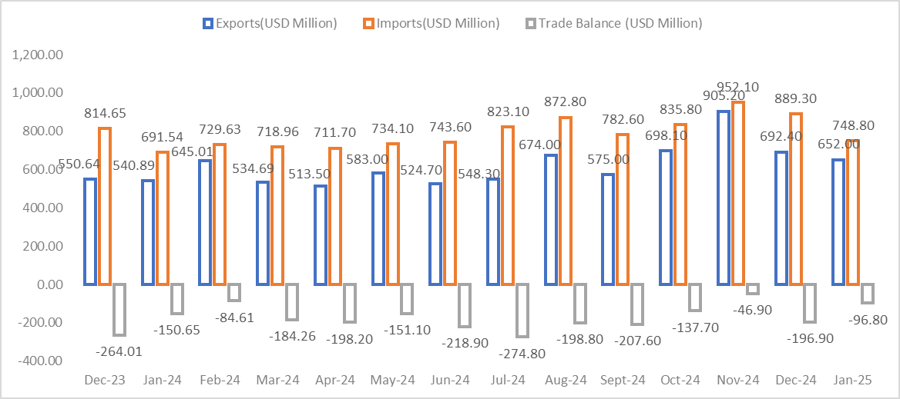

*Source: RBZ (2025)*

# 5.0 Exchange Rate Developments

## **5.1 ZWG Exchange Rate Developments**

5.1.1 During the period under review, the ZWG lost value against the USD, GBP, EUR and ZAR by 0.74%, 2.08%, 0.76% and 1.09% respectively. The ZWG also lost value against all major currencies on a year-on-year basis as shown in Table 2

Table 2: ZWG Exchange Rate Movements-Month Ending 28 February 2025

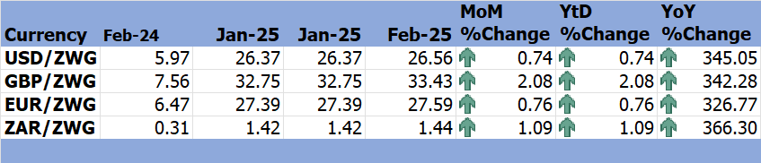

*Source: RBZ (2024 & 2025)*

## **5.2 Parallel Market Developments**

5.2.1 The parallel market exchange rate slightly dropped from USD/ZWG31 to USD/ZWG30 during the first week of February 2025 and maintained that rate throughout the month. On the other hand, the official exchange rate steadily increased from USD/ZWG26.38 and closed the month at USD/ZWG26.56. These trends led to a reduced exchange rate premium, see Figure 2. The reduction in market premium was due to a tight monetary stance by the RBZ.

Figure 2: Parallel Market Developments – February 2025

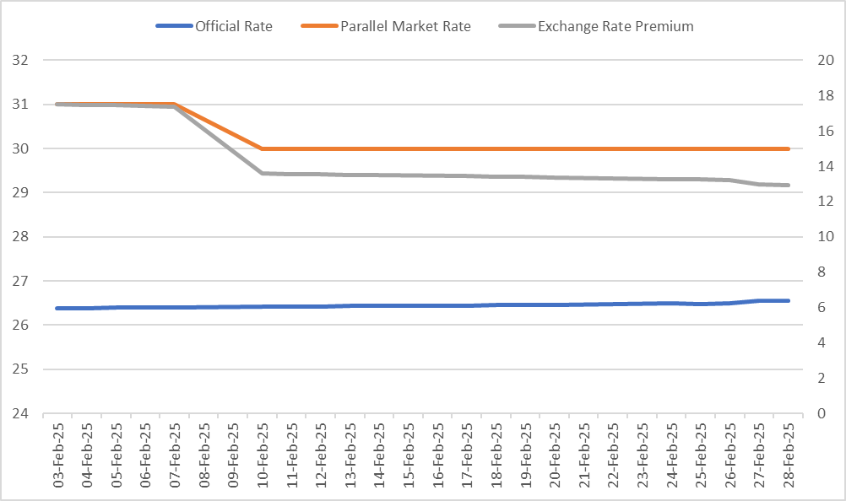

*Source: RBZ and Harare Streets (2025)*

## **5.3 Cross Rate Developments**

5.3.1 In February 2025, the USD depreciated against the GBP, EUR, and ZAR by 1.3%, 0.01%, and 0.36% respectively. On a year-on-year basis, the USD gained by 0.63% and 4.29% against the GBP and the EUR respectively. However, the USD also lost against the ZAR by 3.93%, as shown in Table 3. According to Invesco (2025), the weakening of the USD is due to Trump’s disruptive policies such as the Federal budget cuts, layoffs, and rapid shifts in tariffs which have hit business and consumer confidence.

Table 3: USD Exchange Rate Movements–Month Ended 28 February 2025

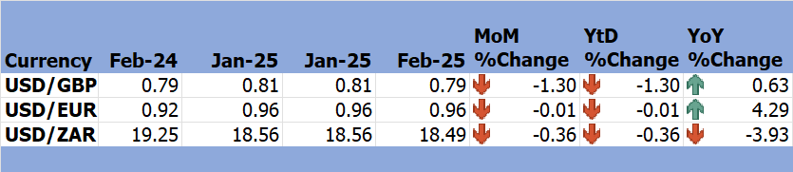

*Source: RBZ (2024 & 2025)*

5.3.2 The trend inhibited by the USD if maintained, especially against the ZAR makes Zimbabwe’s exports cheaper hence encouraging exports to South Africa, the country’s major trading partner.

# 6.0 Inflation Developments

6.1 Month-on-month ZWG inflation sharply declined from 10.5% to 0.5% in February 2025, see Figure 3.

Figure 3: Month-on-Month ZWG Inflation Outturn

*Source: ZimStat (2025)*

6.2 M-o-M weighted inflation also followed suit and dropped from 11.6% in January to 0.3% in February 2025 (see Figure 4). This significant decline suggests a growing stability of prices as businesses and consumers adjust to the prevailing market conditions (The Herald, 2025).

Figure 4: Month-on-Month Weighted Inflation Outturn

*Source: ZimStat (2025)*

6.3 Food and non-alcoholic drinks, as well as housing, water, electricity, gas, and other fuels, continue to be the largest drivers of inflation in February 2025 (see Table 4).

Table 4: Monthly Inflation for February 2025

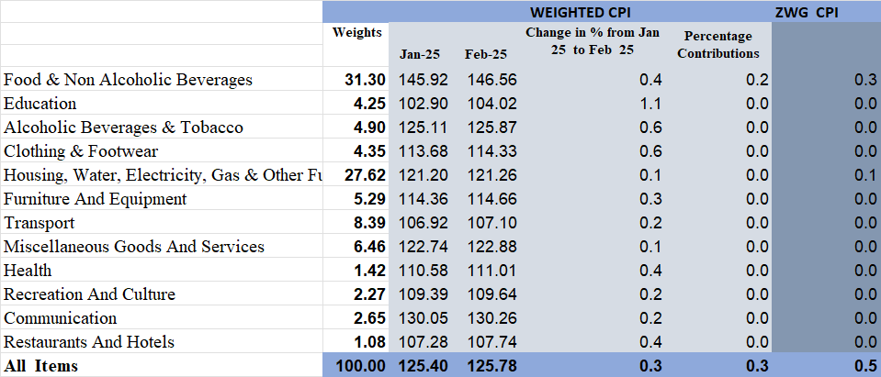

*Source: ZimStat (2025)*

# Monetary Developments

## **7.1 Money Supply**

7.1.1 By the time of compiling this report, February 2025 money supply statistics had not been published thus analysis is based on January 2024 data.

7.1.2 Broad money stock stood at ZWG87.12 billion in January 2025, a 0.38% decline from ZWG87.45 billion recorded in December 2024, see Figure 5. According to RBZ (2025), the foreign currency component of the money supply grew by 0.62%. Money supply stock comprised foreign deposits (84.08%), local currency deposits (115.8%), and local currency in circulation (0.12%). Money supply stock dropped by 0.38% in January 2025.

Figure 5: Broad Money (M3) Supply

*Source: RBZ (2024)*

## **7.2 Interest Rates**

7.1.1 As of 28 February 2025, the average commercial bank deposit rate for savings in local currency was reviewed upward to 3.81% minimum and 4.14% maximum, also it was reviewed to 1.69% minimum and 1.72% maximum in foreign currency. Regarding the weighted lending rate on foreign currency, the minimum rate for individuals was raised to 12.81% while the maximum rate was lowered to 17.25%, the minimum rate for corporates was also raised to 10.93% while the maximum rate was reduced to 16.03%. Weighted lending rates on local currency for both individuals and corporates were reviewed upwards, see Table 5.

Table 5: Interest Rates as of 28 February 2025

|  |  |  |  |  |  |
| --- | --- | --- | --- | --- | --- |
| **Classification** | | **Minimum (%)** | | **Maximum (%)** | |
|  | | **17/01/25** | **28/02/25** | **17/01/25** | **28/02/25** |
| Average Commercial Bank Deposit Rates | Local Currency | 3.38 | 3.81 | 3.54 | 4.14 |
| Foreign Currency | 1.35 | 1.69 | 1.57 | 1.72 |
| Commercial Banks Weighted Lending Rates (Forex) | Individuals | 12.79 | 12.81 | 17.33 | 17.25 |
| Corporates | 10.62 | 10.93 | 16.34 | 16.03 |
| Commercial Banks Weighted Lending Rates (ZWG) | Individuals | 41.60 | 43 | 47.12 | 48.6 |
| Corporates | 40.16 | 40.45 | 45.9 | 45.68 |

*Source: RBZ (2025)*

7.1.2 According to the RBZ (2025), the current interest rates are considered appropriate to sustain the current restrictive monetary policy stance and the anticipated economic growth.

# 8.0 Stock Market Developments

## **8.1 Zimbabwe Stock Exchange (ZSE)**

8.1.1 The ZSE continued to record bearish sentiments on a month-on-month basis. All Share Index, Top 10 Index, and market capitalization fell by 3.63%, 4.18%, and 3.72%, respectively, while value traded rose by 523.18%, see Table 6.

8.1.2 On year-on-year, all selected indices gained except All Share Index (-10.39%).

Table 6: Zimbabwe Stock Exchange Movements

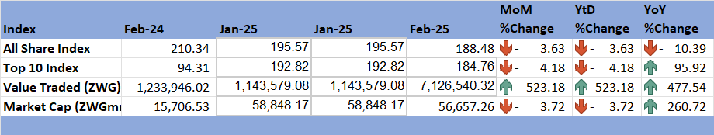

*Source: ZSE (2025)*

## **8.2 Victoria Falls Stock Exchange (VFEX)**

8.2.1 The VFEX also recorded a bearish trend in February 2025, with a decline in All Share Index (-0.86%), value traded (-69.71%), and market capitalization (10.3%). All indices gained on a YoY basis, see Table 7.

Table 7: Victoria Falls Stock Exchange Movements

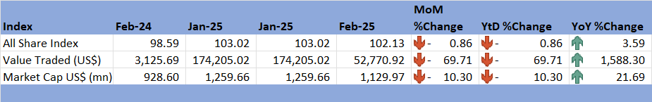

*Source: VFEX (2025)*

# 9.0 Recommendations

9.1 The following recommendations are being proposed:

**9.1.1 Preserve Macroeconomic Stability through Coordinated Fiscal and Monetary Policy**

The country should maintain a tight monetary policy stance in the short term to consolidate the recent disinflation trend and preserve exchange rate stability. Fiscal discipline must complement this monetary stance by avoiding unbudgeted expenditures that could weaken macroeconomic fundamentals and undermine confidence in ZiG.

**9.1.2 Enhance Export Diversification and Value Addition**

To cushion the economy from global commodity price volatility, the country should intensify efforts to diversify its export base. This includes promoting value addition in key mineral sectors such as gold, nickel, and platinum group metals. Additionally, the development of agro-processing value chains and the promotion of non-traditional exports will enhance foreign exchange earnings and support inclusive economic growth.

**9.1.3 Strengthen Agricultural Resilience and Food Security**

Given the softening global prices for major crops, it is imperative for the country to support climate-smart agricultural practices and expand irrigation infrastructure. The establishment of strategic reserves for essential imports like fuel, fertilizer, and grain will further shield the economy from external shocks and improve food security.

**9.1.4 Leverage Regional Exchange Rate Dynamics to Boost Exports**

The depreciation of the USD against the South African Rand presents an opportunity to improve Zimbabwe’s export competitiveness in its largest trading partner’s market. This can be achieved by offering targeted incentives to exporters, streamlining export procedures, and improving efficiency at border posts.

**9.1.5 Deepen Trade Relations with Emerging Export Destinations**

Zimbabwe should capitalize on its growing trade relations with countries such as China and the United Arab Emirates. This includes negotiating favourable trade agreements, enhancing trade facilitation mechanisms, and addressing logistical constraints that hinder efficient market access.

**9.1.6 Continue Reducing the Exchange Rate Premium**

Sustained efforts are needed to narrow the gap between the official and parallel exchange rates. These include improving the availability of foreign currency through formal banking channels, reinforcing public confidence in the ZiG currency, and maintaining consistency in policy communication to foster trust among economic agents.

**9.1.7 Revitalize Capital Markets and Encourage New Listings**

Investor confidence in Zimbabwe’s capital markets must be strengthened through regulatory reforms, increased transparency, and targeted investor education. Encouraging more listings, particularly from mining, energy, and agro-industrial companies, on both the ZSE and VFEX will enhance access to long-term capital and broaden participation in formal financial markets.

# 10 References

Bradstock, F. (2025). *Key Commodity Trends to Watch in 2025*. Retrieved from OILPRICE.COM: https://oilprice.com/Energy/Energy-General/Key-Commodity-Trends-to-Watch-in-2025.html#:~:text=Key%20Commodity%20Trends%20to%20Watch%20in%202025%201,for%20electric%20vehicles%20and%20energy%20storage%20solutions%20increases.

International Monetary Fund. (2025). *World Economic Outlook, January 2025 Update.* IMF.

Invesco. (2025). *Why do we expect further weakening of the US dollar?* Retrieved from https://www.invesco.com/apac/en/institutional/insights/market-outlook/why-do-we-expect-further-weakening-of-the-us-dollar.html?msockid=15dc0a15f93065382a851e5cf8436478

RBZ. (2025). *2025 Monetary Policy Statement.* Reserve Bank of Zimbabwe.

RBZ. (2025). *Exchange Rates*. Retrieved from Reserve Bank of Zimbabwe: https://www.rbz.co.zw/index.php/research/markets/exchange-rates

Reserve Bank of Zimbabwe. (2025). *Monthly Economic Review: January 2025.* RBZ.

Reserve Bank of Zimbabwe. (2025). *Weekely Economic Highlights, 28 February 2025, Vol 27 No 9.* Reserve Bank of Zimbabwe.

The Herald. (2025). *Zim Inflation in Major Downtrend*. Retrieved from https://www.herald.co.zw/zim-inflation-in-major-downtrend/

Trading Economics. (2025). *Commodities*. Retrieved from Trading Economics: https://tradingeconomics.com/commodity/crude-oil

UN. (2025). *World Economic Situation and Prospects: February 2025 Briefing, No. 187*. Retrieved from United Nations: https://www.un.org/development/desa/dpad/publication/world-economic-situation-and-prospects-february-2025-briefing-no-187/#:~:text=The%20world%20economy%20has%20shown%20remarkable%20resilience%2C%20with,commodity%20prices%2C%20and%20monetary%20easing%20in

VFEX. (2025). *Main Dashboard*. Retrieved from Victoria Falls Stock Exchange: https://www.vfex.exchange/

World Bank. (2025). *Food Security Update.* World Bank.

ZimStat. (2025). *Inflation Rates*. Retrieved from Zimbabwe Statistics Agency: https://www.zimstat.co.zw/

ZSE. (2025). *Main Dashboard*. Retrieved from Zimbabwe Stock Exchange: https://www.zse.co.zw/

**NECF Secretariat, 2025**